|  |  |
| --- | --- |
| **Ex. No. 8** | **Working with Angular JS Directives** |
| Date of Exercise: | 10/10/2022 |
| Drive Link | shorturl.at/vyBM9 |
| GitHub Link: | https://pavitrapati.github.io/urk20cs2017/exp8/exp8.html |

**Aim**

To build simple programs like BMI calculator, To-do list, and Calculator using Angular JS.

**Description**

AngularJS is an open JavaScript framework developed and maintained by

Google. It implements the MVC (Model View Controller) pattern to separate data, presentation and logical components.

Angular.js follows the MVC architecture. The Controller represents the layer that has the business logic. User events trigger the functions which are stored inside your controller. The user events are part of the controller.

Views are used to represent the presentation layer which is provided to the end users. Models are used to represent your data. The data in your model can be as simple as having primitive declarations. For example, if you are maintaining a student application, your data model could just have a student id and a name. Or it can also be complex by having a structured data model. If you are maintaining a car ownership application, you can have structures to define the vehicle's engine capacity, seating capacity, etc.

**HTML Code**

<!DOCTYPE html>

<html lang="en">

<head>

    <meta charset="UTF-8">

    <meta http-equiv="X-UA-Compatible" content="IE=edge">

    <meta name="viewport" content="width=device-width, initial-scale=1.0">

    <title>Experiment-8</title>

    <script type="text/javascript" src="http://ajax.googleapis.com/ajax/libs/angularjs/1.0.7/angular.min.js"></script>

    <script type="text/javascript">

        function myCtrl($scope) {

            $scope.bmi_calc = function () {

                var w = $scope.weight;

                var h = $scope.height;

                //var bmi = $scope.weight / ($scope.height * $scope.height);

                var bmi = w / (h * h);

                if (bmi < 18.5) {

                    $scope.output = 'Under weight';

                    //return 'Under weight';

                } else if (bmi >= 18.5 && bmi < 25) {

                    $scope.output = 'Normal';

                    //return 'Normal';

                } else if (bmi >= 25 && bmi < 30) {

                    $scope.output = 'Over weight';

                    //return 'Over weight';

                } else if (bmi > 30) {

                    $scope.output = 'Obese';

                    //return 'Obese';

                }

            }

        };

        function FrmController($scope) {

            $scope.comment = [];

            $scope.btn_add = function () {

                if ($scope.txtcomment != "") {

                    $scope.comment.push($scope.txtcomment);

                    $scope.txtcomment = "";

                }

            }

            $scope.remItem = function ($index) {

                $scope.comment.splice($index, 1);

            }

        };

        function todoController($scope) {

            $scope.tasks = [];

            $scope.Add = function () {

                if ($scope.todoTask != "") {

                    $scope.tasks.push($scope.todoTask);

                    $scope.todoTask = "";

                }

            }

            $scope.remitem = function ($index) {

                $scope.tasks.splice($index, 1);

            }

        };

    </script>

    <script type="text/javascript">

        angular.module('CalculatorApp', [])

            .controller('CalculatorController', function ($scope) {

                $scope.result = function () {

                    if ($scope.operator == '+') {

                        return $scope.a + $scope.b;

                    }

                    if ($scope.operator == '-') {

                        return $scope.a - $scope.b;

                    }

                    if ($scope.operator == '*') {

                        return $scope.a * $scope.b;

                    }

                    if ($scope.operator == '/') {

                        return $scope.a / $scope.b;

                    }

                };

            });

    </script>

    <style>

        body{

            padding-left: 15%;

        }

        .div1 {

            display: flexbox;

            width: 80%;

            border-style: outset;

            border-radius: 20px;

            background-color: rgb(73, 163, 168);

            padding: 20px;

            margin-top: 10px;

            margin-left: 10px;

        }

        .flex-container {

            display: flexbox;

            background-color: DodgerBlue;

            padding-left: 20px;

        }

        .flex-container>button {

            background-color: #f1f1f1;

            margin: 5px;

            padding: 5px;

            font-size: 20px;

        }

    </style>

</head>

<body ng-app="CalculatorApp">

    <div class="div1" ng-app="">

        <form ng-controller="FrmController">

            Post Your Comment <br>

            <textarea ng-model="txtcomment" placeholder="Your Comment" style="width:550px"></textarea>

            <br>

            <button ng-click="btn_add();" style="margin-top:10px;">

                Post Comment

            </button>

            <h4>Comments</h4>

            <ul>

                <li ng-repeat="comnt in comment">{{comnt}}

                    <a style="float:right" href="" ng-click="remItem($index)">x</a>

                </li>

            </ul>

        </form>

    </div>

    <div class="div1" ng-controller="CalculatorController">

        <h4>Calculator</h4>

        <p><input type="number" ng-model="a"></p>

        <p><input type="number" ng-model="b"></p>

        <p><select ng-model="operator">

                <option>+</option>

                <option>*</option>

                <option>-</option>

                <option>/</option>

            </select></p>

        <p>{{ result() }}</p>

    </div>

    <div class="div1" ng-controller="todoController">

        To-DO <br>

        <textarea ng-model="todoTask" placeholder="tasks" style="width:550px"></textarea>

        <br>

        <button ng-click="Add();" style="margin-top:10px;">

            Add

        </button>

        <h4>Tasks</h4>

        <ul>

            <li ng-repeat="t in tasks">{{t}}

                <a style="float:right" href="" ng-click="remitem($index)">x</a>

            </li>

        </ul>

    </div>

    <div class="div1">

        <h2> BMI Calculator </h2>

        <br>

        <hr><br>

        <div ng-init="output='Testing'" ng-controller="myCtrl">

            Enter weight : <input type="text" ng-model="weight" ng-init="weight=78"> <br>

            Enter height : <input type="text" ng-model="height" ng-init="height=1.8"> <br>

            <button ng-click="bmi_calc()">Click</button>

            <br><br>

            <p> {{output}}</p>

        </div>

    </div>

</body>

</html>

**OUTPUT**

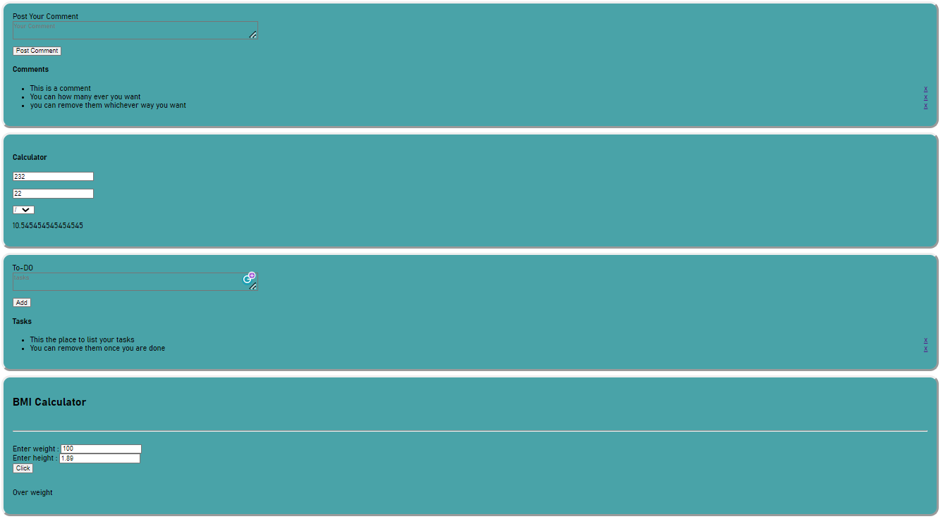

**RESULT**

The programs were done successfully using Angular JS.